**Smart IoT System for Automated Rain Detection, Window Control, and Gas Leak Safety**

**ProjectOverview:**  
Designed and implemented a smart IoT system using the ESP32 microcontroller to automatically detect rain, control windows, and monitor gas leaks for enhanced safety and convenience. The system integrates real-time environmental sensing with intelligent automation to respond effectively to changing conditions.

**Key Features:**

* Automated rain detection triggers window control to prevent water damage.
* Continuous gas leak monitoring ensures early detection and alerts for safety.
* Remote monitoring and control via cloud platforms for user convenience.
* Intelligent decision-making using machine learning algorithms for adaptive responses.

**Technologies & Tools Used:**

* **Hardware:** ESP32 microcontroller
* **Programming:** Python (automation logic), Arduino IDE
* **Cloud Integration:** Firebase, Adafruit IO for real-time data streaming and alert notifications
* **Communication Protocol:** MQTT for lightweight messaging
* **Machine Learning:** K-Nearest Neighbors (KNN) algorithm for environmental data classification and response automation

**Impact:**  
This project demonstrates the integration of IoT hardware with cloud services and machine learning to create a smart, responsive system that improves safety and home automation capabilities.

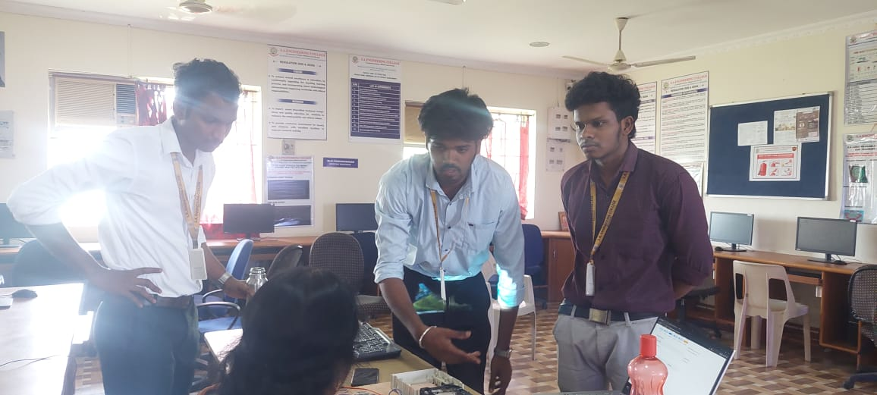

Project teamates

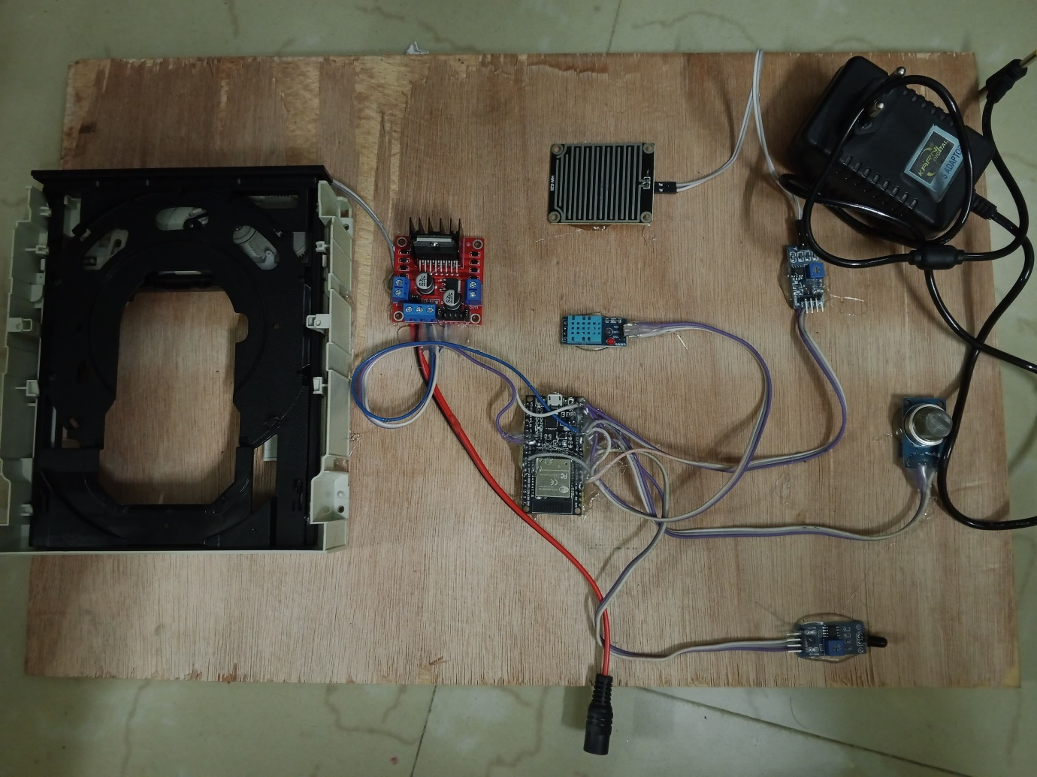

**Hardware of the project**